WorkshopPLUS – Power Apps for Power User 1 Day

Module 3: Building with controls, fields, and formulas

Student Lab Manual

Instructor Edition (Book Title Hidden Style)

**Conditions and Terms of Use**

Microsoft Confidential

This training package is proprietary and confidential, and is intended only for uses described in the training materials. Content and software is provided to you under a Non-Disclosure Agreement and cannot be distributed. Copying or disclosing all or any portion of the content and/or software included in such packages is strictly prohibited.

The contents of this package are for informational and training purposes only and are provided "as is" without warranty of any kind, whether express or implied, including but not limited to the implied warranties of merchantability, fitness for a particular purpose, and non-infringement.

Training package content, including URLs and other Internet Web site references, is subject to change without notice. Because Microsoft must respond to changing market conditions, the content should not be interpreted to be a commitment on the part of Microsoft, and Microsoft cannot guarantee the accuracy of any information presented after the date of publication. Unless otherwise noted, the companies, organizations, products, domain names, e-mail addresses, logos, people, places, and events depicted herein are fictitious, and no association with any real company, organization, product, domain name, e-mail address, logo, person, place, or event is intended or should be inferred.

**Copyright and Trademarks**

© 2020 Microsoft Corporation. All rights reserved.

Microsoft may have patents, patent applications, trademarks, copyrights, or other intellectual property rights covering subject matter in this document. Except as expressly provided in written license agreement from Microsoft, the furnishing of this document does not give you any license to these patents, trademarks, copyrights, or other intellectual property.

Complying with all applicable copyright laws is the responsibility of the user. Without limiting the rights under copyright, no part of this document may be reproduced, stored in or introduced into a retrieval system, or transmitted in any form or by any means (electronic, mechanical, photocopying, recording, or otherwise), or for any purpose, without the express written permission of Microsoft Corporation.

For more information, see Use of Microsoft Copyrighted Content at

<http://www.microsoft.com/en-us/legal/intellectualproperty/Permissions/default.aspx>

DirectX, Hyper-V, Internet Explorer, Microsoft, Outlook, OneDrive, SQL Server, Windows, Microsoft Azure, Windows PowerShell, Windows Server, Windows Vista, and Zune are either registered trademarks or trademarks of Microsoft Corporation in the United States and/or other countries. Other Microsoft products mentioned herein may be either registered trademarks or trademarks of Microsoft Corporation in the United States and/or other countries. All other trademarks are property of their respective owners.

Contents

Lab 3: Using Controls, fields, and formulas to add functionality 5

Exercise 1: Add device gallery and connect to data source 6

Exercise 2: Arrange the device gallery 9

Exercise 3: Add gallery to show manufacturers 11

Exercise 4: Connect ManufacturerGallery to manufacturer's table 14

Exercise 5: Highlight the selected item in the gallery 16

Exercise 6: Filter the devices based on selected manufacturer 17

Exercise 7: Configure text labels in the device gallery 18

Exercise 8: Conditional formatting to highlight devices above $1,000 20

Exercise 9: Add a checkbox to add a device to the compare list 21

Exercise 10: Create a collection for the selected devices 23

Exercise 11: Set default selection to the first manufacturer and test the app 26

# Lab 3: Using Controls, fields, and formulas to add functionality

**Introduction**

In this lab, you will perform the actions necessary for building Power Apps by adding controls, fields, and formulas.

**Objectives**

After completing this lab, you will be able to:

* Add device gallery and connect to data source
* Arrange the device gallery
* Add gallery to show manufacturers
* Connect **ManufacturerGallery** to manufacturer's table
* Highlight the selected item in the gallery
* Filter the devices based on the selected manufacturer
* Configure text labels in the device gallery
* Apply conditional formation to highlight devices above $1,000
* Add a checkbox to add a device to the **Compare** list
* Create a collection for the selected devices
* Set the default selection to the first manufacturer and test the app.

**Prerequisites**

Ensure you are using the “Incognito” or “InPrivate” browsing session of your modern browser.

Additionally, use the latest version of [Microsoft Edge](https://support.microsoft.com/en-us/help/4501095/download-the-new-microsoft-edge-based-on-chromium) (aka Edge Chromium) for the best performance.

**Estimated time to complete this lab**

45mins

**Scenario**

The organization wishes to build apps using the Power Apps platform to take advantage of **No Code/Low Code** application development in the cloud. As part of this effort, you are required to add controls and create formulas to add functionality to your app.

## Exercise 1: Add device gallery and connect to data source

In this exercise, you will add a gallery of all available devices, making it easy for users to browse the list and get a quick overview of available devices.

1.

Select the

**Insert**

tab

.

2.

Select **Gallery** and then select **Horizontal**.

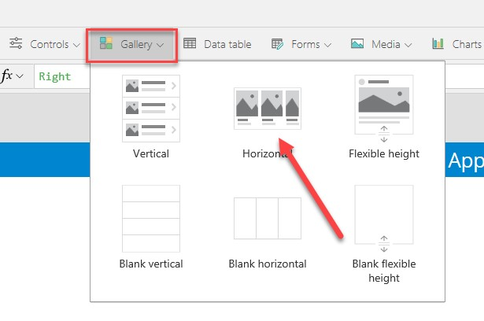

This will add a gallery called **Gallery1** to the screen. Notice how the control tree view on the left displays this gallery with three controls within it – two labels and one image. A data pane will pop-up on the right.

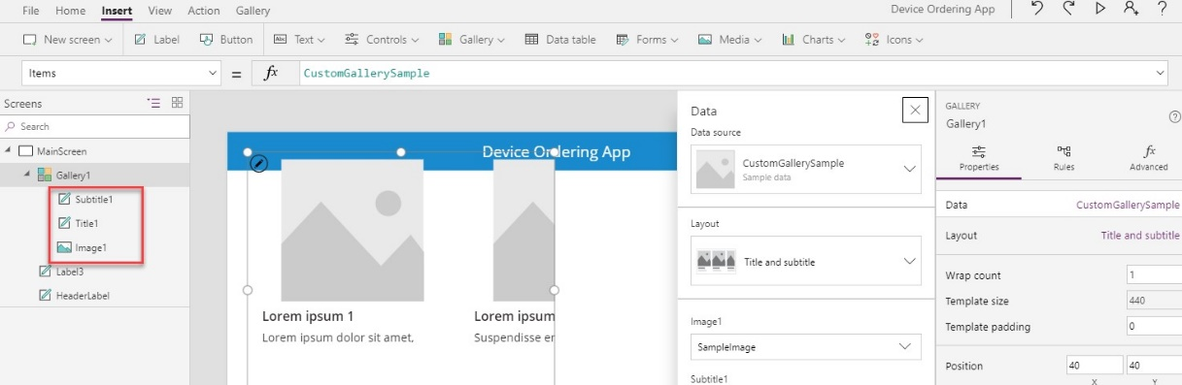

1. Go to the **Properties** pane, select the **Data Source** dropdown, and then select **Add a data source**.

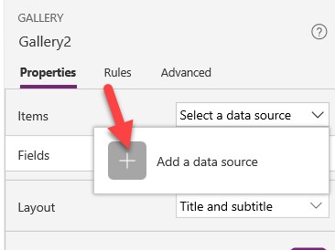

**Note**: on newer tenants the experience might look as shown below:

1. Select **Import from Excel**.

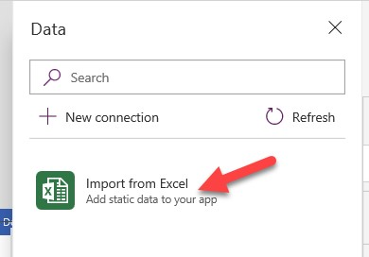

1. In the File Open dialog, browse to the location where you unzipped the data file (e.g., C:\AIAD\PAHandsOnLabContent\) and select **Device-Order-Data.xlsx** to load it.

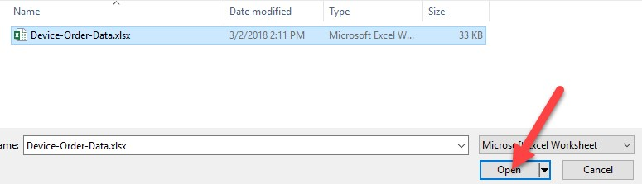

1. Select both tables – **Devices** and **Manufacturers**, and select the **Connect** button. This will add both these tables as static data in the application.

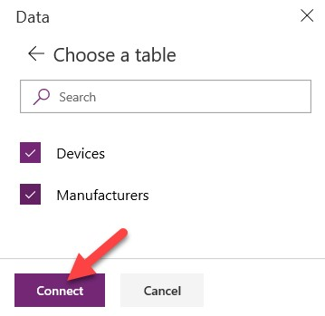

**Note**: In this lab, you will work with tables imported from a static data file and embedded as resources in the app. If you were building a real solution, the same tables would likely be stored in the cloud, such as in a SharePoint list, an SQL table, or a Common Data Service entity.

1. Close the data pane.
2. Select **Gallery1** and set the **Data source** property to **Devices**. The gallery will get populated with data.

9.

Rename **Gallery1** to **DeviceGallery**.

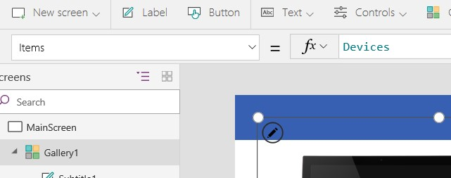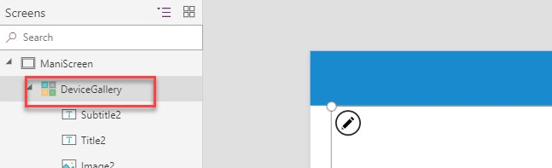

**Tips on working with galleries:**

Galleries provide a powerful way to visualize tabular data in Power Apps. It is important to become familiar with customizing a gallery. Key components of a gallery include the gallery control, the template cell (first cell), and controls within the template cell.

To select the entire gallery – click on the gallery in the tree view on the left or click on the second or third cell. Clicking any cell that is not the first cell of the gallery will select the entire gallery. Now, you can specify properties that apply to the entire gallery, such as the data source, the gallery fill color, and borders.

To customize how each item is displayed in the gallery, you will customize the template cell. Select the template by clicking the first cell of the gallery or the edit (pencil) icon  in the top left corner when the entire gallery is selected.

You can now add, remove, and customize the controls within the template cell. These changes will repeat across each item or row in the table.

Go ahead and select the device image in the template cell and change its size. Notice how the size of the image changes in all the cells.

You can also test your gallery on the canvas by holding down the **Alt** key to activate.

You will customize the device gallery in subsequent steps.

## Exercise 2: Arrange the device gallery

1.

Resize and reposition the gallery.

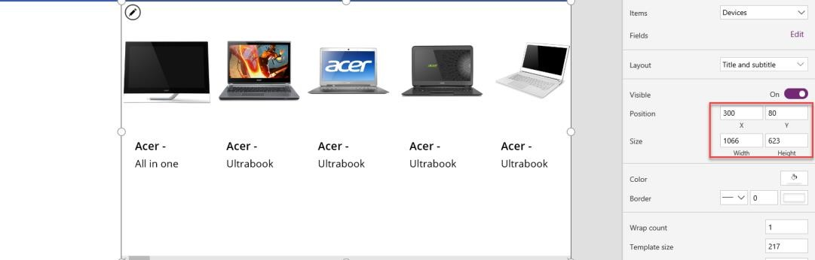

1. Select **DeviceGallery** and click the edit(pencil) icon on the top left to edit the template cell.

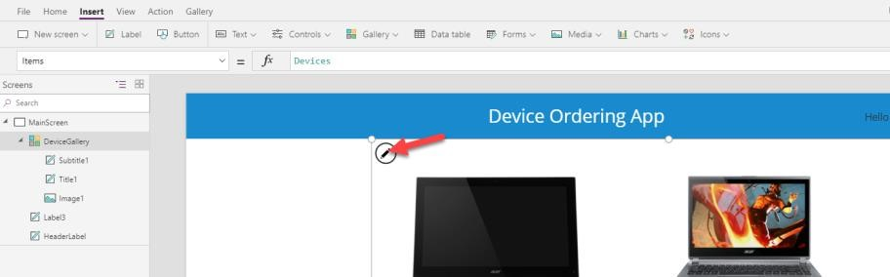

1. Using the right drag control, resize the first box to be narrower. Notice how all the items get narrower, and more devices become visible on the screen.

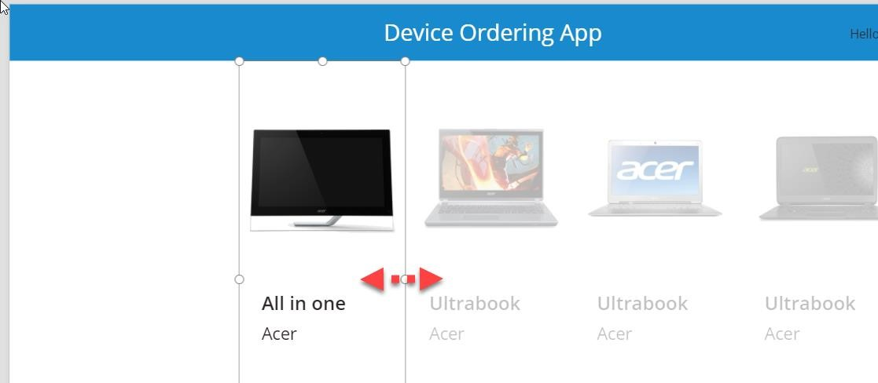

1. Narrow the image by clicking on the image control and resizing it using the drag handles. Make sure the width of the image control is positioned within the template.

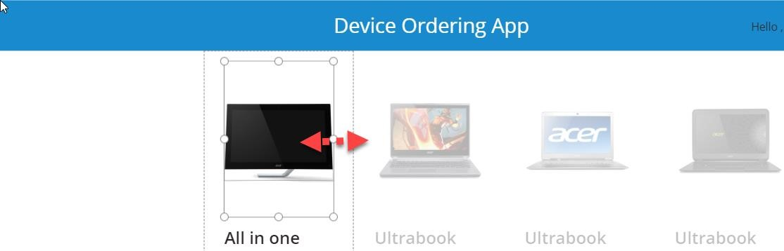

## Exercise 3: Add gallery to show manufacturers

In this task, you will add a second gallery that will list the various device manufacturers. This will be a single-column vertical gallery on the left side of the screen; each cell displaying the manufacturer’s logo image. This gallery will later be used as a filter for the device gallery created above.

1. Select **MainScreen**.
2. Select the **Insert** tab on the ribbon and open the **Gallery** drop-down. Then select **Vertical**.

3.

Rename the gallery to **ManufacturerGallery**.

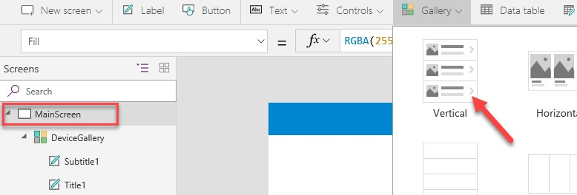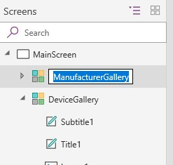

1. Close the data pane.
2. Move this new gallery so that it is left-aligned with the left edge of the screen and top-aligned with the top of the device gallery. These two galleries should like the image below:

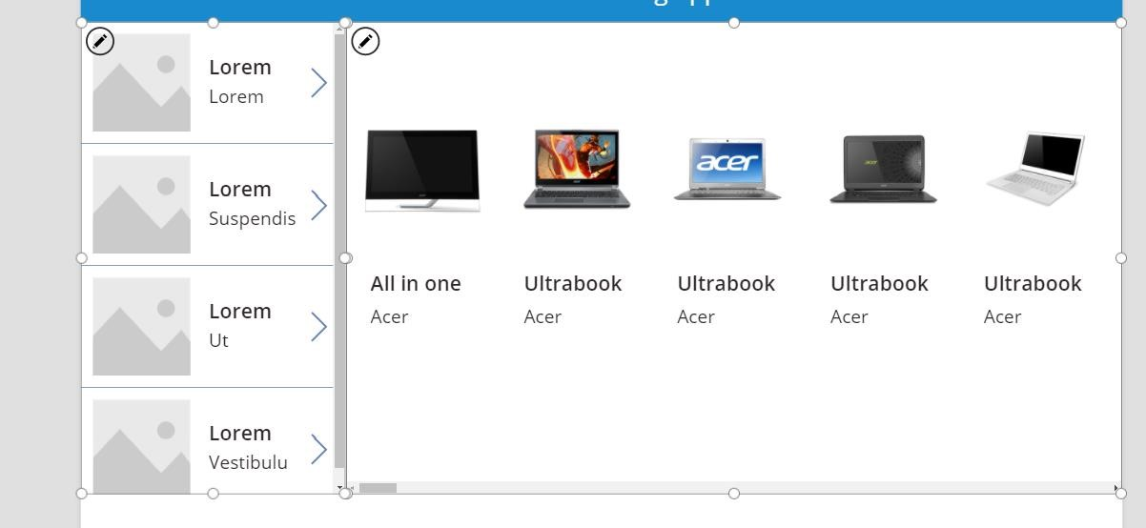

1. Select **ManfacturerGallery** (not just the template cell), in the **Properties** tab on the right, and then click **Layout**.

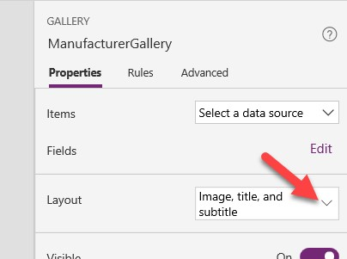

1. Scroll down to the **Gallery** section and select **2 columns**.

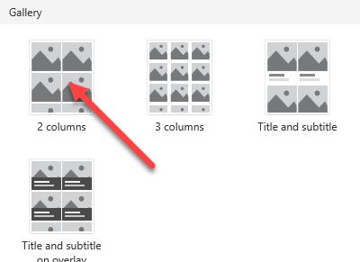

1. Change the **Wrap count** from **2** to **1**. This will change it to a single-column gallery.

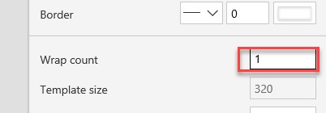

1. Select the image control within the gallery (the edit pencil icon) and **reduce its height** by dragging the bottom middle drag-control upwards. The image size will reduce, whereas the template size will stay expanded.

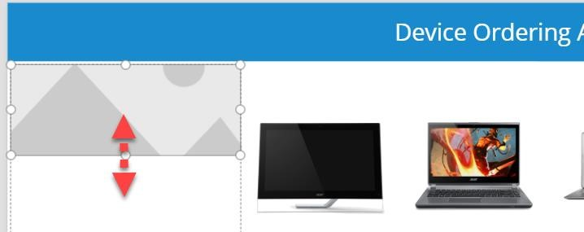

1. Reduce the height of the template cell to match the image below. We want the image to occupy the entire cell.

11.

Click on **File**, and **Save** the application.

12.

Click on the back arrow.

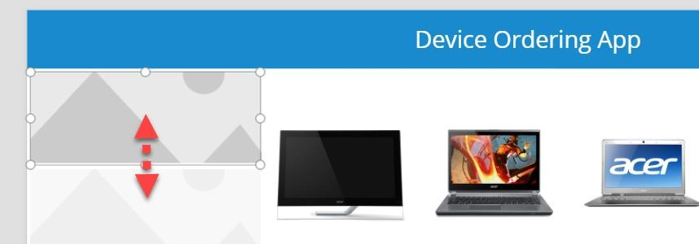

## Exercise 4: Connect ManufacturerGallery to manufacturer's table

Earlier you connected the data source using the data tab in the right pane. The steps given below will show you how to connect to data via the formula bar.

1. Select **ManufacturerGallery**. Make sure the whole gallery is selected and not just the first cell.
2. Select **Items** from the property drop-down next to the formula bar and type **Manufacturers** in the formula bar. The gallery gets populated with images of buildings. This is because Power Apps picked a default binding which mapped to the HQ column in the table.

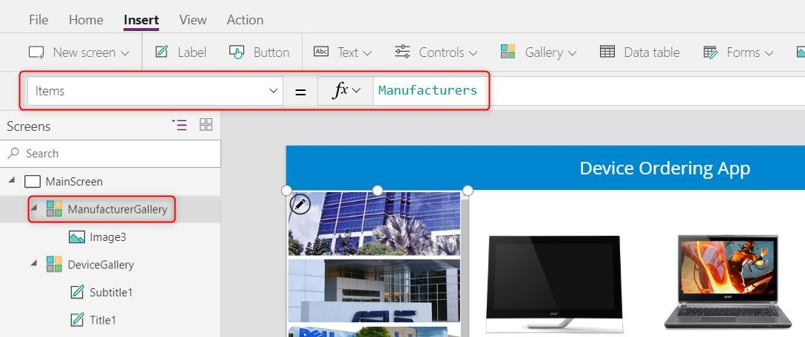

1. Select the image control in the first template cell in the gallery and change the value of **Image** in the formula bar from **ThisItem.HQ** to **ThisItem.Logo**. All the gallery items will now display logo images. You can also use the left tree view to select the controls - sometimes that is easier.

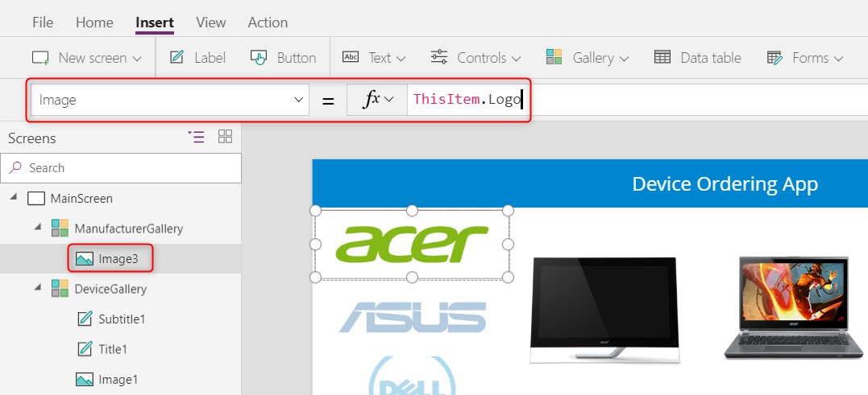

1. Select the first (top-most) image and using the **Properties** pane on the right set the **Image position** property to **Fit**.

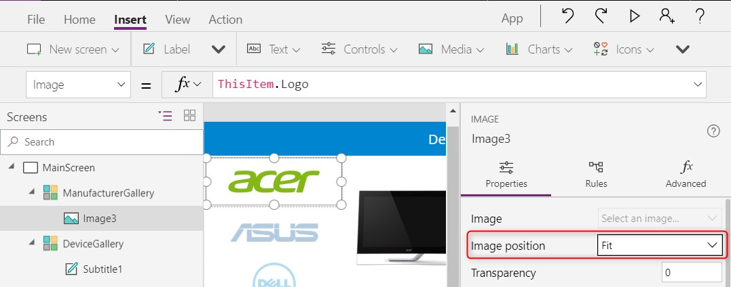

1. Reduce the height of the template cell such that all nine manufacturers fit without a scrollbar. To do this, use the drag handles to reduce the height of the image and subsequently reduce the height of the template cell. To select the template cell, select the entire gallery, and click on the edit (pencil) icon in the top left.

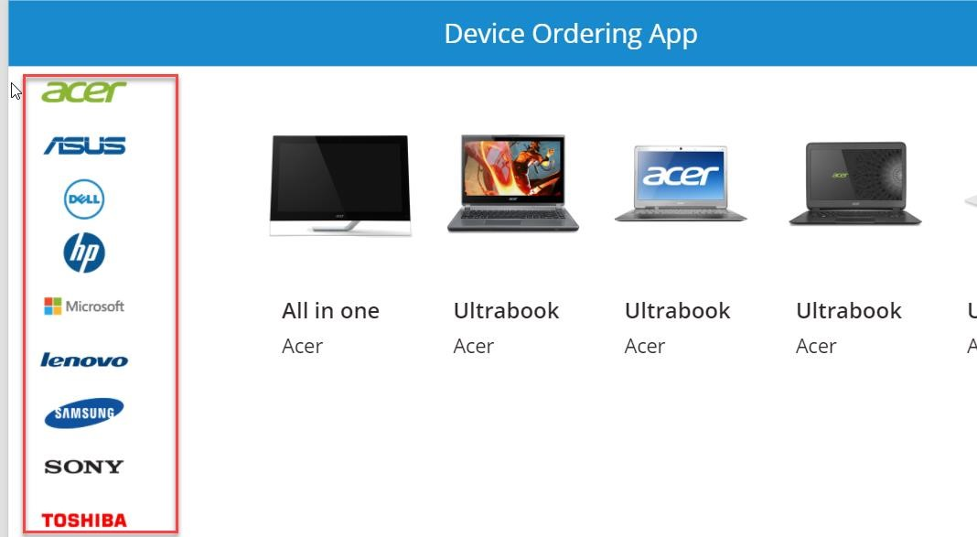

## Exercise 5: Highlight the selected item in the gallery

In this task, you will use the **TemplateFill** property of the manufacturer gallery to specify a highlight color for the selected item.

1. With the whole gallery selected, set the **TemplateFill** property to: If(ThisItem.IsSelected,ColorFade(HeaderLabel.Fill,75%))

This will conditionally set a **Fill** color if the cell is selected.

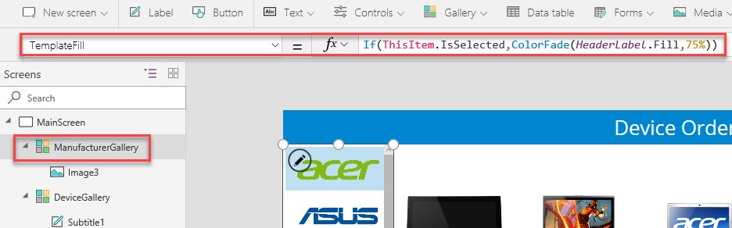

You could set a specific color or RGB value, but we recommend using the **ColorFade** function so that it matches the header label with a 75% fade. If you change the fill color of header label, the template fill color will automatically change.

1. Now try using the preview mode to perform a quick test of this highlighting. You can enable preview mode by holding down the **Alt** key (also known as the **Option** key) and clicking a few different manufacturers in the gallery. Notice that the selected item is highlighted in a light blue color. The preview mode ends when you stop holding down the **Alt** key.

Alternatively, you could click the **Play** button to enter preview mode. To exit this mode, click on **X** in the upper right corner or use the **Esc** key.

## Exercise 6: Filter the devices based on selected manufacturer

In this task, you will use the **Filter()** function to filter items in the **DeviceGallery** to only display devices that match the selected item in the **ManufacturerGallery**.

1. Select **DeviceGallery**. With the **Items** property selected, enter the following expression in the formula bar:

Filter(Devices, ManufacturerID = ManufacturerGallery.Selected.ManufacturerID)

 For alternate/European locales:

Filter(Devices; ManufacturerID = ManufacturerGallery.Selected.ManufacturerID)

This will filter the device gallery to display only those items that match the selected manufacturer based on **ManufacturerID**.

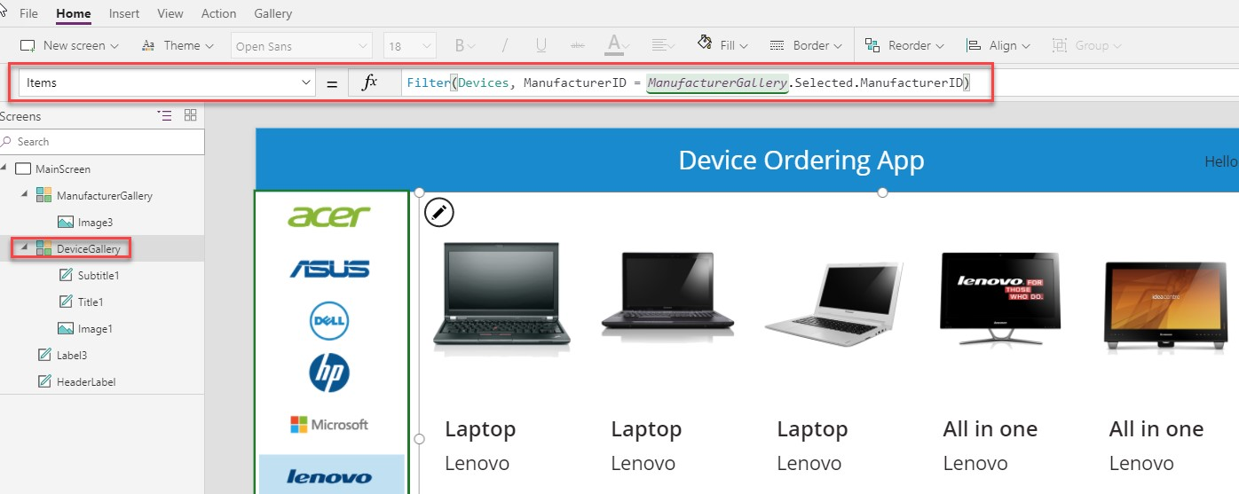

1. Select a different item in the manufacturer gallery on the left, and you will notice that the device gallery updates accordingly. **Note**: In some cases, the first few items won’t show the selection. Try selecting the 5th or 6th item if that occurs.

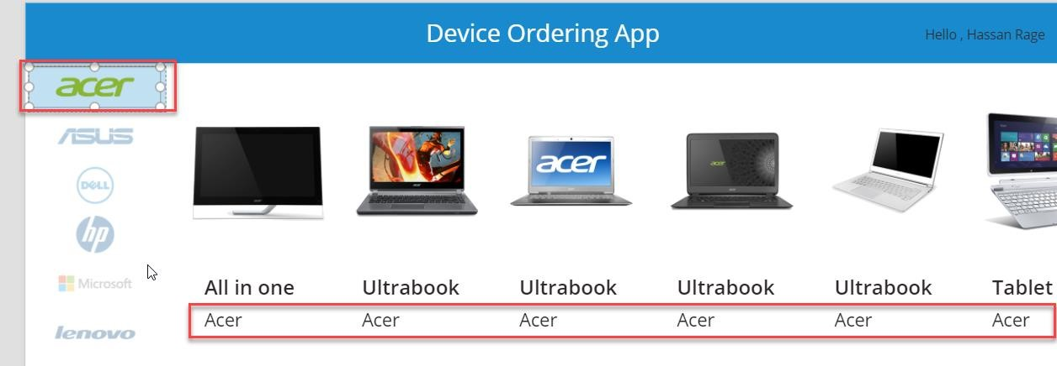

**Note:** If you get an error when entering the **Filter** command, check the name of the manufacturer gallery. The name in the filter command must match the name of your gallery.

## Exercise 7: Configure text labels in the device gallery

1. Select the title in the **DeviceGallery**. It is named **Title1** in the left-side control navigation. It may have the default value set to the **DeviceType** property (for example, Tablet).
2. Change the label to display the device name by setting the label’s **Text** property to **ThisItem.Title**.

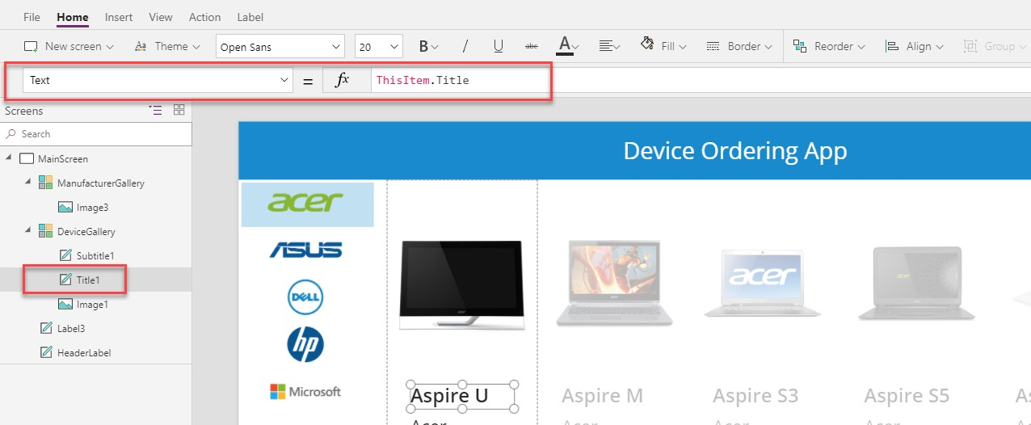

Here are some additional formatting suggestions. These are for cosmetic purposes only, feel free to skip these:

* Expand the width of the label to the template width.

Notice that the second label expands as well. This is because **X** property is set to **Title1.X**, the **X** coordinate position of the **Title1** label. For more on the relative positioning of controls, see: <https://powerapps.microsoft.com/blog/ux-patterns-control-positioning/>

* Change **PaddingLeft** from **0** to **10**.
* Change the font to **Segoe UI**.

1. Select **Subtitle1**.
2. In the property drop-down list, select the **Text** field and change it from **ThisItem.ManufacturerName** to **ThisItem.Price**.

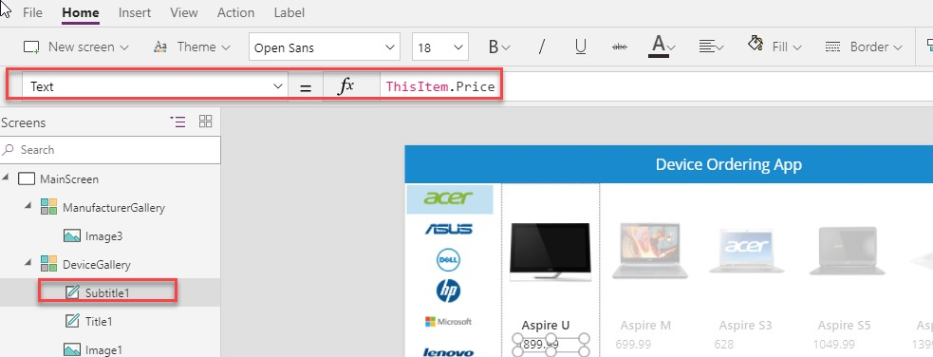

1. To add **$**, use the text format expression:

Text(ThisItem.Price,"$##,###.00")

For alternate/European locales: Text(Price;"$##.###,00")

**Note:** After you enter the above value in the formula bar, it will automatically resolve to include your locale, e.g. [$-en-US]. If you see an error here, it might be because your locale is not yet supported, in which case as a workaround, manually change it to [$-en-US].

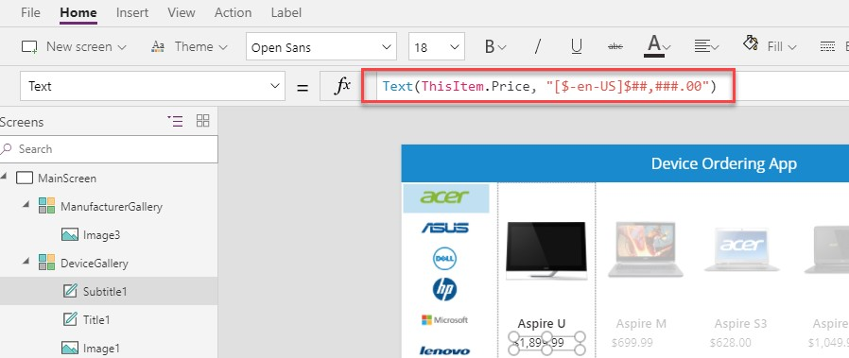

**Optional UI enhancement:**

* Change the value of **PaddingLeft** property of **SubTitle1** label from **0 to 10**. Or set it to **Title1.PaddingLeft**.
* Change the font to **Segoe UI**.

## Exercise 8: Conditional formatting to highlight devices above $1,000

We can make it easy to spot devices that cost more than $1,000 by displaying the price in red.

1. Select the label in the template cell that displays the price and set **Color** to

If(ThisItem.Price>1000,OrangeRed,Gray)

For alternate/European locales: If(Price>1000;OrangeRed;Gray)

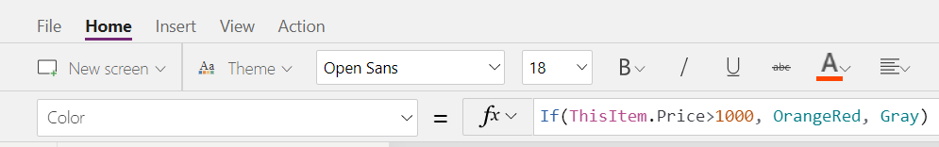

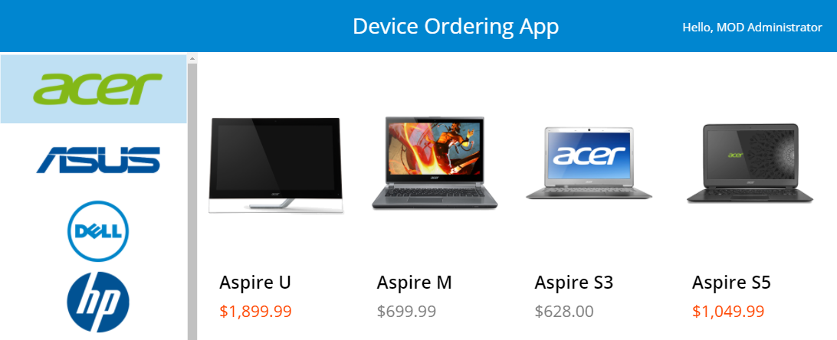

**Note**: As you are typing this formula, notice that autosuggest shows a choice of matching colors. Power Apps comes with a set of standard colors that you can easily reference in any property that accepts a color value. You can also set specific RGB values.

For a full list of color functions and colors, see: <https://powerapps.microsoft.com/tutorials/function-colors/>

1. Click **File** and select **Save**.

3.

Click the back arrow.

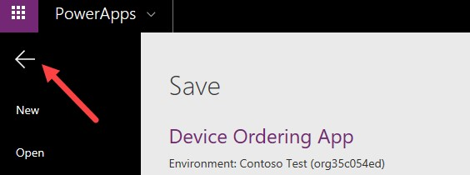

## Exercise 9: Add a checkbox to add a device to the compare list

We want to allow users to select multiple devices to compare before making a final selection on the next screen.

1. Select **DeviceGallery**. Click the edit (pencil) icon in the top left of the gallery to select the template cell.

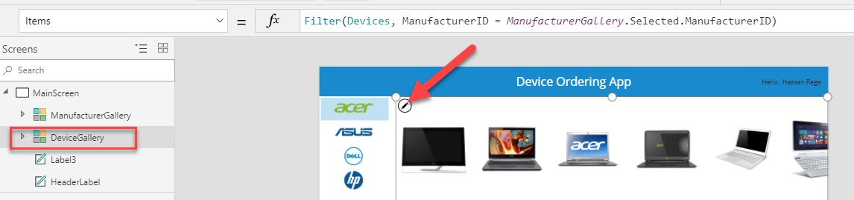

1. Make sure only the first item in the gallery is selected, not the entire gallery.

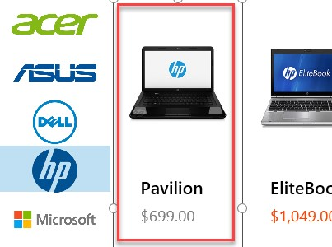

1. Add a checkbox by clicking **Insert** à **Inputs** à **Checkbox**.

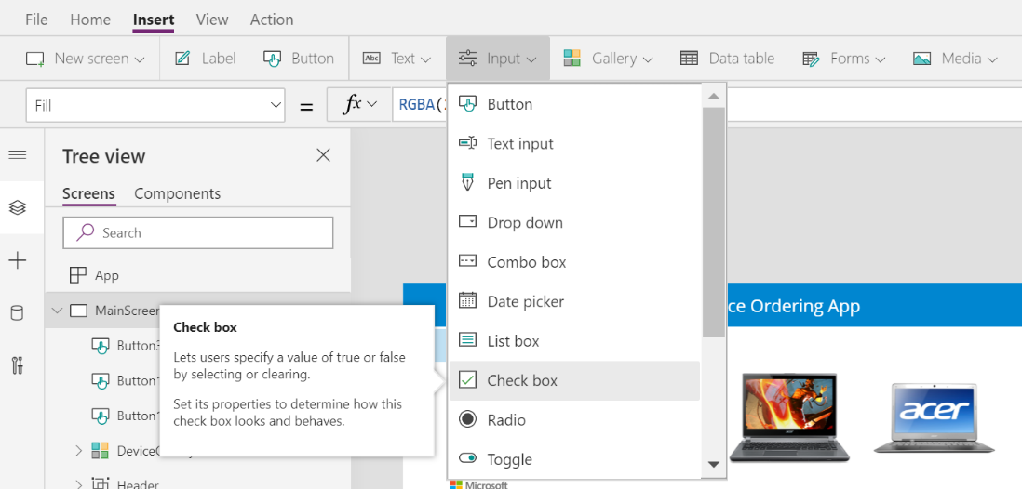

1. Move the inserted checkbox below the price.

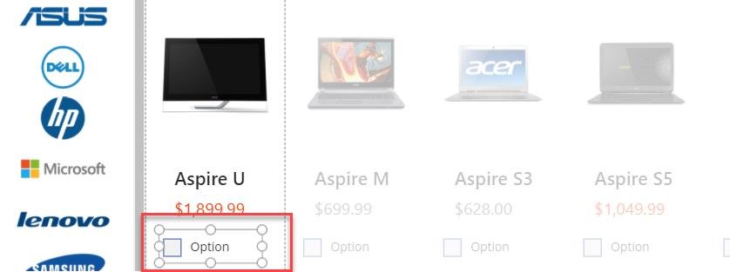

1. Change the checkbox text to Compare. You can either do this by setting the **Text** property or clicking within the text of the control and typing directly into the control.

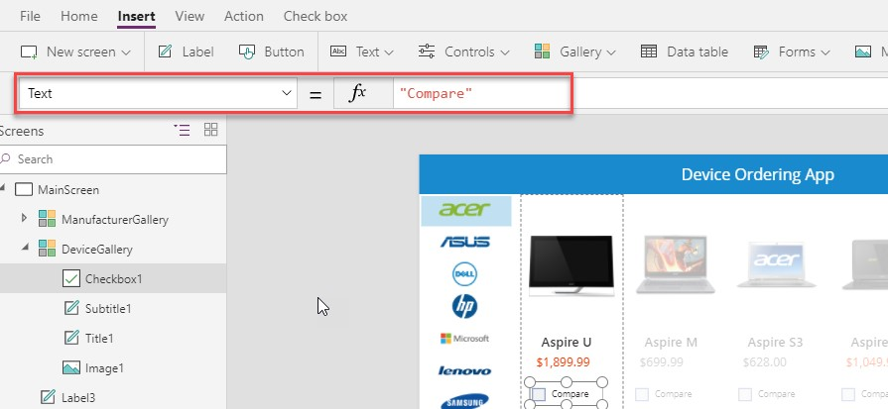

## Exercise 10: Create a collection for the selected devices

When a user selects a device to compare, we will add it to a collection called **CompareList**. You can think of this as an in-memory collection of devices that have been selected for comparison.

1. Select the **Checkbox** control and click on the **Action** tab in the ribbon, click **OnCheck,** and set the value in the formula bar to Collect(CompareList,ThisItem).

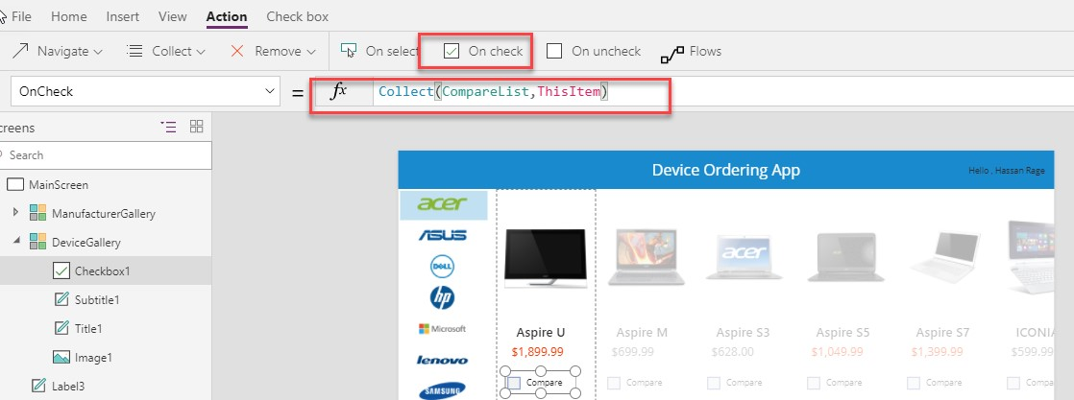

1. Set the **OnUncheck** value to Remove(CompareList,ThisItem)



1. Set the **Default** property of the checkbox to ThisItem in CompareList.

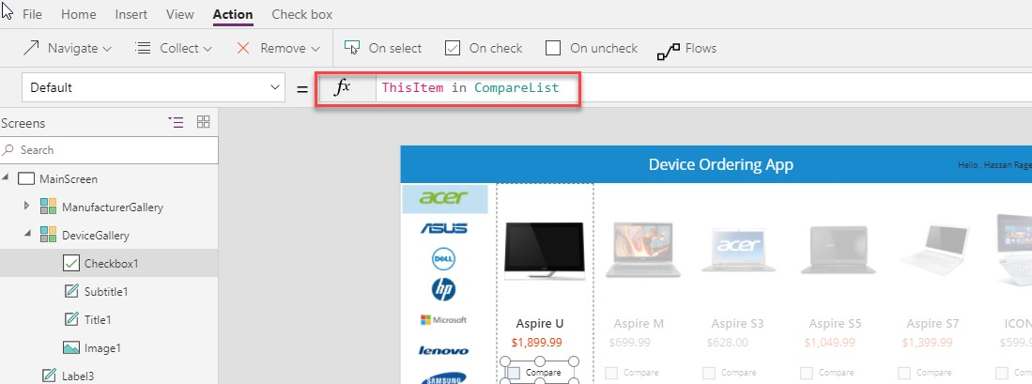

The default setting of the checkbox is a boolean (true or false) value. It determines if the checkbox should be checked by default, or not. Setting it to this formula will ensure that the checkbox is checked by default because the item has already been added to the collection since the result is **true**, that is, this item *is* in **CompareList**.

1. Let’s test out adding items to a collection by running the app in **Preview** (F5) mode or by clicking the **Preview** button on the top right. Click the checkboxes for three of the devices.

5.

Close the p

review.

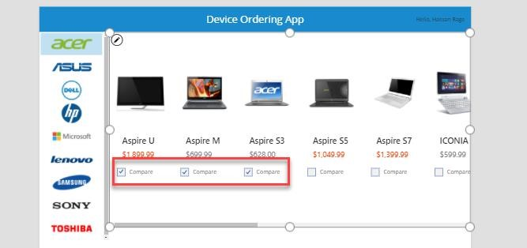

1. Click the **View** tab and select **Collections**.

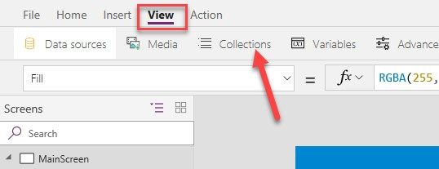

1. You will see the **CompareList** collection and the three items you selected.

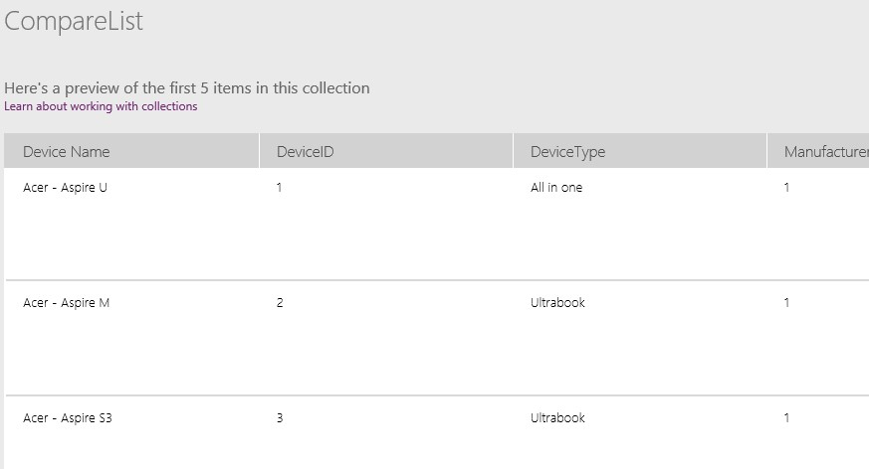

Note that each item in the collection has all the information that we get from the **Machines** data source, not just the fields we display in the **Devices Gallery**.

1. Click the back arrow on the top left to get back to the main view.

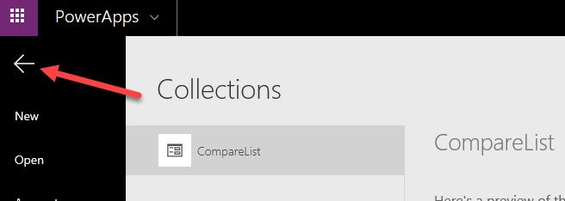

1. Click **Preview** again.
2. Uncheck all the checked items close the preview mode.

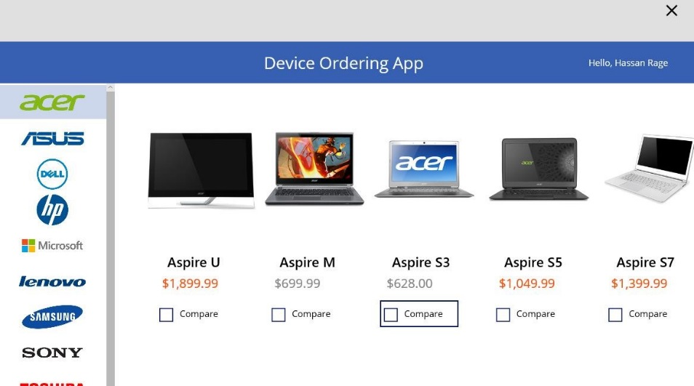

1. Click the **View** tab and select **Collections**.



1. All items will be removed from the **CompareList** collection.
2. Click on the back arrow.

## Exercise 11: Set default selection to the first manufacturer and test the app

To avoid getting a blank list of devices when the app starts, set the default selected item in the Manufacturer gallery to be the first item.

1. Select theentire gallery (by clicking **ManufacturerGallery** in the tree view on the left), and set the **Default** property of the gallery in the formula bar to First(Manufacturers).

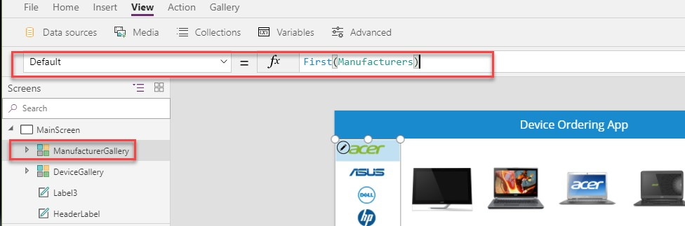

This will set it to the first item in the table.

1. To preview the app, press the **Preview** button on the upper right of the top menu. Pressing the **F5** key will also preview the application.

**Note**: You can also test your app on the canvas by holding down the **Alt** key to activate buttons and other controls, as well as double-clicking to type into controls.

1. Your app should look like the image below:

4.

To exit preview mode, click

**X**

in the top right corner.

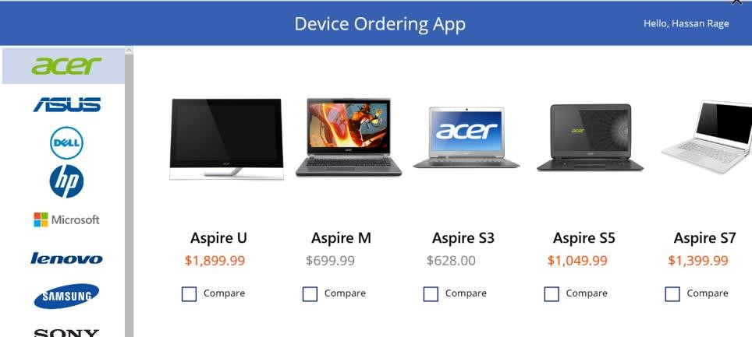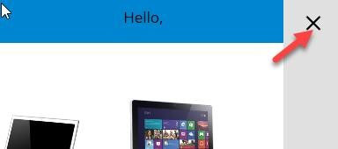

5. Save the application.